- Purpose
To define and provide guidelines and instructions for selecting and approving suppliers who provide services.

- Scope
This procedure applies to the qualification of all contractors for GCP, GLP, GMP or other services that directly affect the quality of EPIC products.

- Definitions
Contractor | Any organization or company that on contract provides purchased items or services.
GCP | Good Clinical Practices
GLP | Good Laboratory Practices
GMP | Good Manufacturing Practices
Confidentiality Agreement/NDA | Agreement between EPIC Research & Diagnostics, Inc. and Contract Supplier or other service provider that binds each to confidentiality.
Request for Proposal | Document produced by EPIC Research & Diagnostics, Inc. explaining the products or services required of a Contract Supplier.
Approved Supplier | A supplier that has completed the approval process defined in this procedure.
Audit | An evaluation of a supplier’s quality system including procedures, policies and records. Typically either an on-site audit (at the supplier’s facility) or from a self-survey form that is sent to the supplier, completed by them and returned.

- Responsibilities
User | - Complies with the policy and procedure for all new or revised documents.  - Ensures the most current version of this document is used when referenced.
Departmental Management | - Ensures departmental personnel are properly trained before using this policy or procedure.  - Provides a timely review and approval/rejection of a draft document.
Quality Assurance | - Complies and enforces the document control standards within this document.  - Monitors the implementation and effectiveness of this document.  - Assists Users and Departmental Management with writing/revising documents.

- Policy
  - All suppliers and consultants will agree to and execute a contract with EPIC before performing any services.
  - All suppliers and consultants will agree to and execute a Confidentiality Agreement/NDA with EPIC before discussing confidential information.

- Procedure
  - Contractor Initiation
    - The applicable department head or designated representative performs all initial research on each contractor/supplier to establish their services, expertise, availability, and capabilities.
    - Execute a Confidentiality Agreement/NDA and if necessary a Request for Proposal/Quote (RFP/Q).
    - Notify Quality Assurance (QA) when the above documentation is in place and provide supplier’s contact information.

  - Contractor Prequalification
    - Verify an NDA has been executed before discussing any confidential information.
    - Using the provided company information, contact the contractor representative and request the following applicable documents be completed and/or forwarded to EPIC:
      - Supplier Quality Questionnaire or Clinical Service Provider Questionnaire
      - SOP Index
      - Organizational Chart
      - Facility Diagram
      - Scope of Services Provided
      - Approved subcontractor list for performing any outside services on EPIC projects
    - For each supplier, prepare a supplier file to house the following applicable documents:
      - Confidentiality Agreement/NDA
      - Quality Agreement
      - Supplier Quality Questionnaire or Clinical Service Questionnaire
      - SOP Index
      - Organizational Chart
      - Facility Diagram
      - List of services and/or analyses provided
      - Approved subcontractor list for performing any outside services on EPIC projects
    - Store and maintain the vendor file alphabetically in either the Supplier files or Clinical Service Provider files.

  - Qualification Process
    - Based on the prequalification materials and information from the involved internal department, determine the type of qualification process required for each supplier. Requirements may be exempted by written justification of the Supplier Approval Team.
    - Review and compare the supplier’s processes, policies, and available documentation and evaluate the contractor’s level of compliance to any applicable industry standards of domestic or international governmental regulations.
    - If necessary, perform an on-site audit following QA-010, External Auditing. File the audit report in the supplier file.

  - Post Qualification Process
    - Based on the documentation review and contractor on-site audit (if performed), approve or reject the contractor.
    - If approved, add the contractor to the Approved Supplier List.
    - Inform the necessary internal department(s) head or designated representative that the contractor has been either approved or rejected.

- References
  - OPS-008, Supplier Qualification
  - OPSF-006, Supplier Quality Questionnaire
  - OPSF-008, Approved Supplier List
  - OPSF-012, Clinical Service Provider Questionnaire
  - QA-010, External Auditing

- Attachments
Attachment A – Confidentiality Agreement/NDA

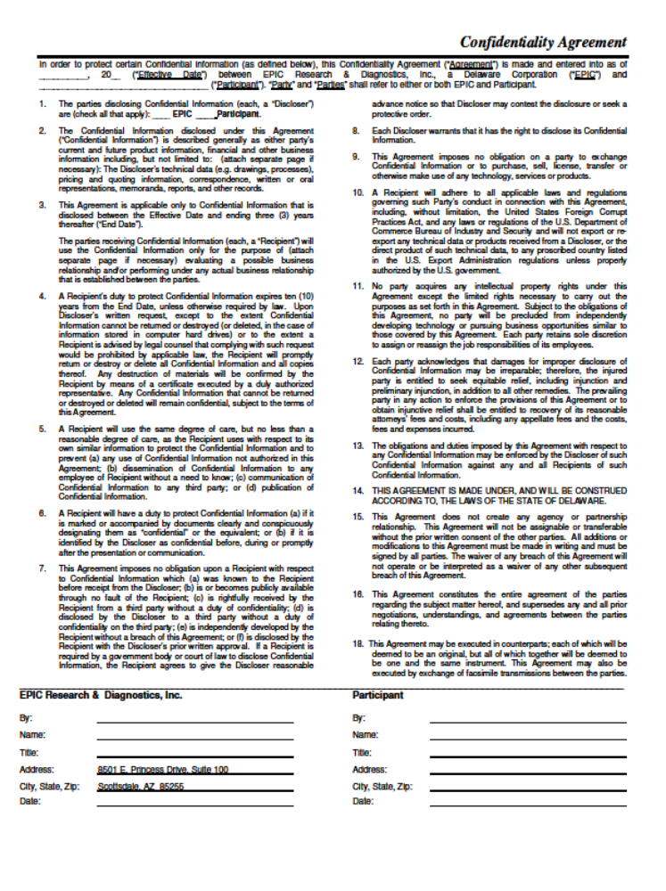

Document Revision History
Change Order Number: | Version Number: | Description of Change: | Date: | Updated by:
CC-060309-02 | 000 | New Document | 08/07/09 | T. Joiner
CC-110930-01 | 001 | Updates due to supplier qualification changes. | 10/6/11 | J. Ayres

